**Intent Data**

**Daftar isi**

**- Intent data from fragment to fragment in other activity**

**- Intent data from fragment to fragment in other activity(bundle)**

**- Intent data from fragment in one activity to other activity**

**- Intent data from activity to fragment in another activity**

**Intent data from fragment to fragment in other activity**

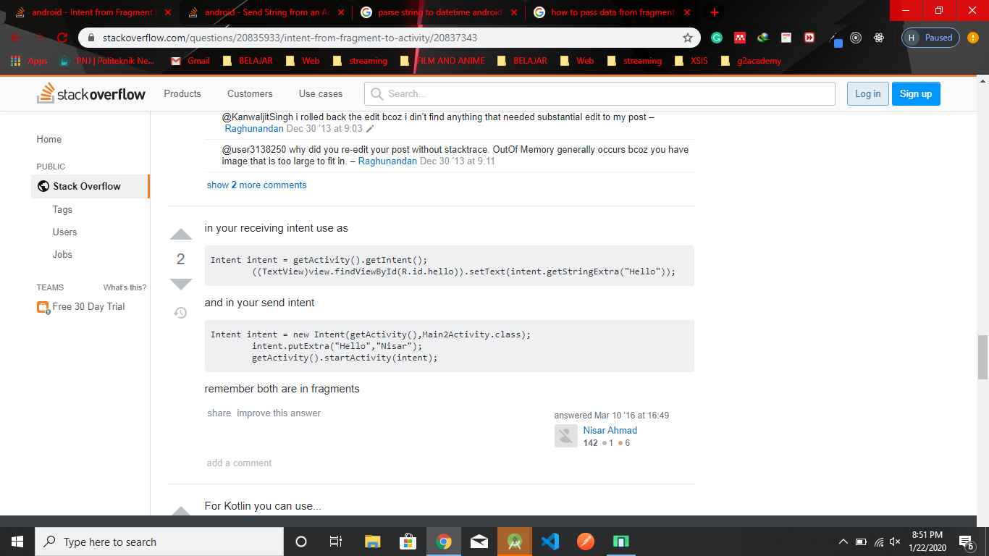

**Intent data from fragment to fragment in other activity(bundle)**

Send

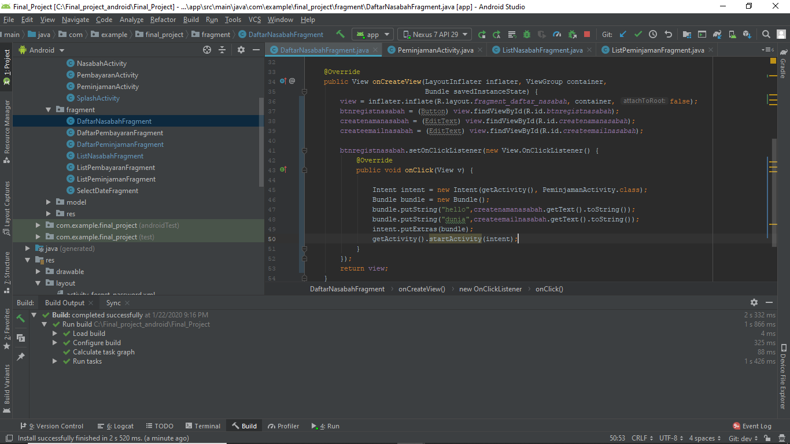

Receive

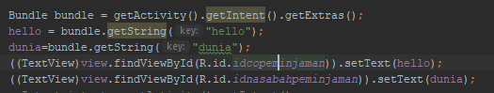

**Intent data from fragment in one activity to other activity**

Send

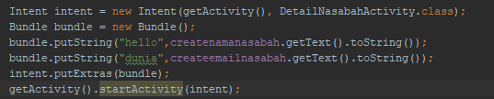

Receive

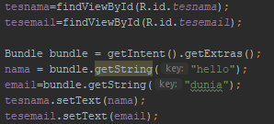

**Intent data from activity to fragment in another activity**

Send

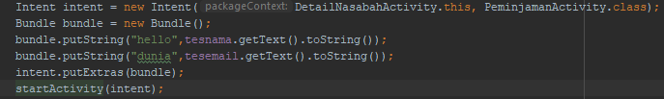

Receive

